SIMATS ENGINEERING
MODEL PRACTICAL EXAMINATION – Aug._2026
COURSE NAME: Artificial Intelligence COURSE CODE: CSA1709
Register Number | 192424390
Name | Venu G

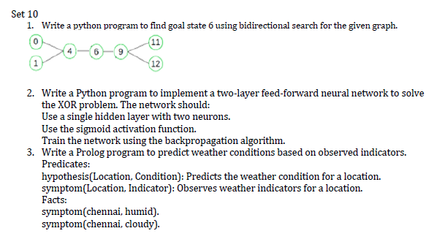

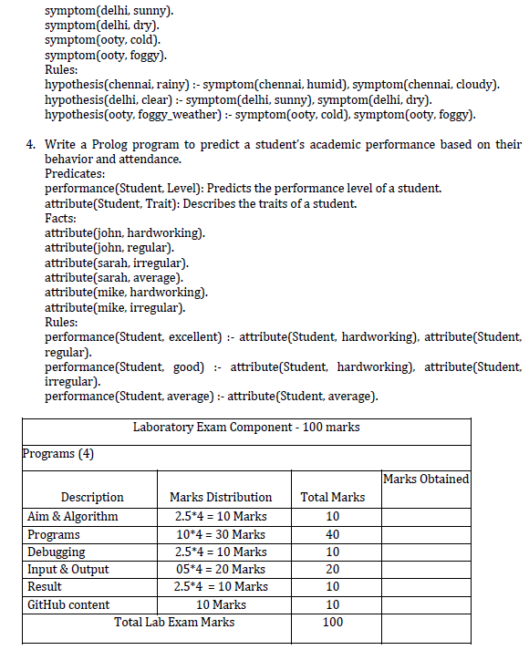

1. Bidirectional Search

Aim
To write a Python program to find the goal state 6 using Bidirectional Search for the given graph.

Algorithm
- Start with the source node and goal node.
- Create two BFS queues:
  - Forward search from the source.
  - Backward search from the goal.
- Maintain visited nodes for both searches.
- Expand nodes alternately from both directions.
- Check whether a node visited by the forward search is also visited by the backward search.
- When the two searches meet, reconstruct the path.
- Display the path from source to goal.

Program
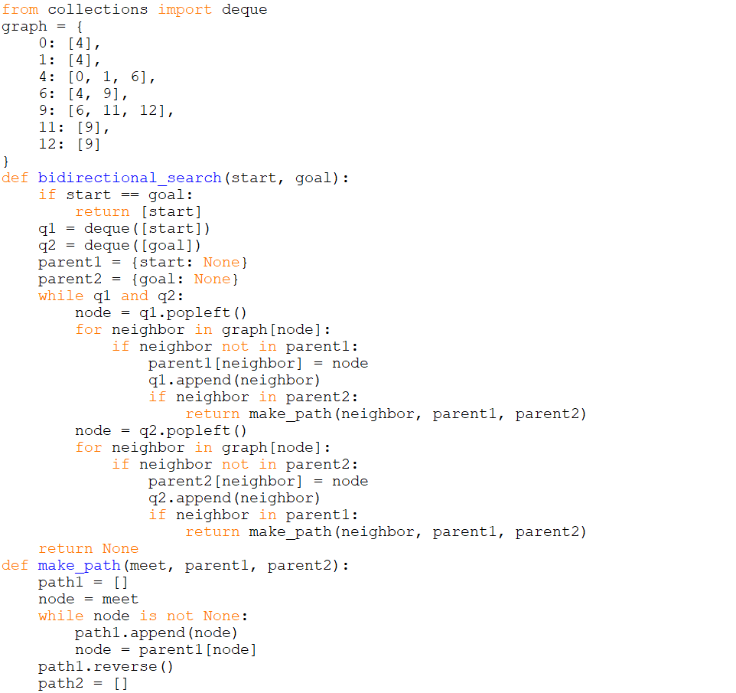

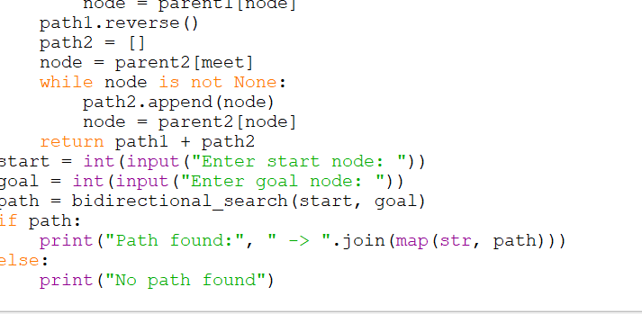

Sample Input And output
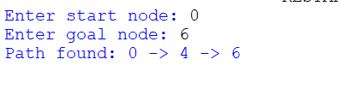

Result
Thus, the Python program successfully finds the path from the start state 0 to the goal state 6 using Bidirectional Search.

2. Two-Layer Feed-Forward Neural Network for XOR

Aim
To write a Python program to implement a two-layer feed-forward neural network with one hidden layer containing two neurons to solve the XOR problem using the sigmoid activation function and backpropagation algorithm.

Algorithm
- Initialize the XOR input and target output.
- Create a neural network with:
  - 2 input neurons
  - 2 hidden neurons
  - 1 output neuron
- Initialize weights and biases with small random values.
- Calculate hidden-layer weighted sum.
- Apply the sigmoid activation function.
- Calculate output-layer weighted sum.
- Apply sigmoid activation function.
- Calculate output error.
- Calculate output and hidden-layer gradients.
Program
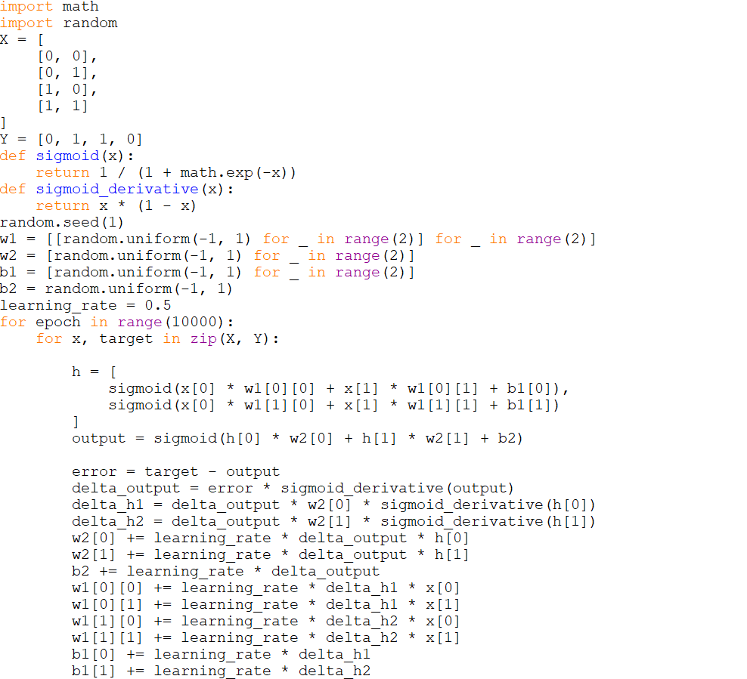
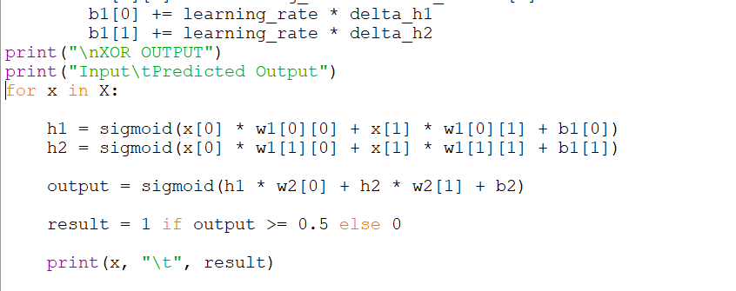

Sample Input
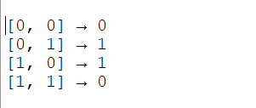

Sample Output
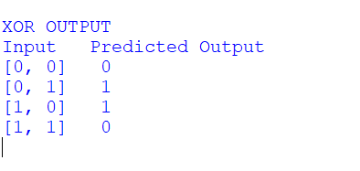

Result
Thus, the two-layer feed-forward neural network successfully learns the XOR function using sigmoid activation and backpropagation.

3. Prolog Program for Weather Prediction

Aim
To write a Prolog program to predict weather conditions based on observed weather indicators using facts and rules.

Algorithm
- Define the predicate symptom(Location, Indicator).
- Add weather indicator facts for different locations.
- Define the predicate hypothesis(Location, Condition).
- Create rules that infer weather conditions from observed symptoms.
- Query the required location.
- Prolog checks the facts and applies the rules.
- Display the predicted weather condition.

Program
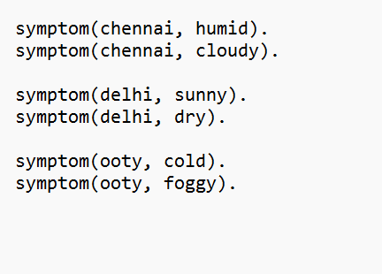
Sample Input
symptom(chennai, humid).
Sample Output
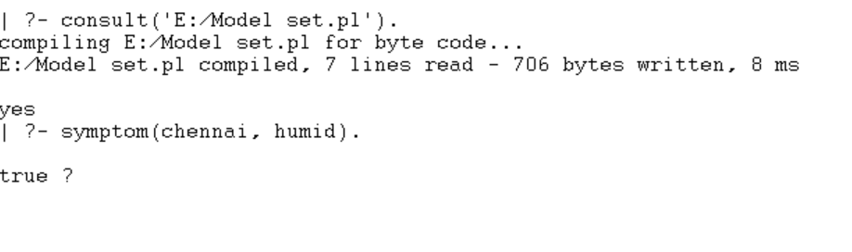

Result
Thus, the Prolog program successfully predicts weather conditions based on the observed weather indicators using facts and logical rules.

4. Prolog Program for Student Academic Performance

Aim
To write a Prolog program to predict a student's academic performance based on their behavior and attendance attributes.

Algorithm
- Define the predicate attribute(Student, Trait).
- Store student behavior and attendance-related traits as facts.
- Define the predicate performance(Student, Level).
- Create rules for:
  - Excellent performance
  - Good performance
  - Average performance
- Query a student's performance.
- Prolog matches the student's attributes with the appropriate rule.
- Display the predicted performance level.
Program
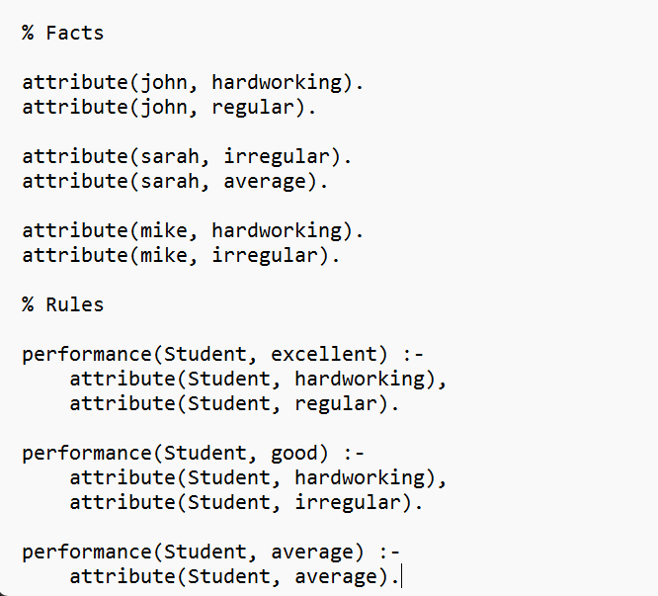
Sample input
performance(john, Level).
attribute(john, hardworking).
Sample Output
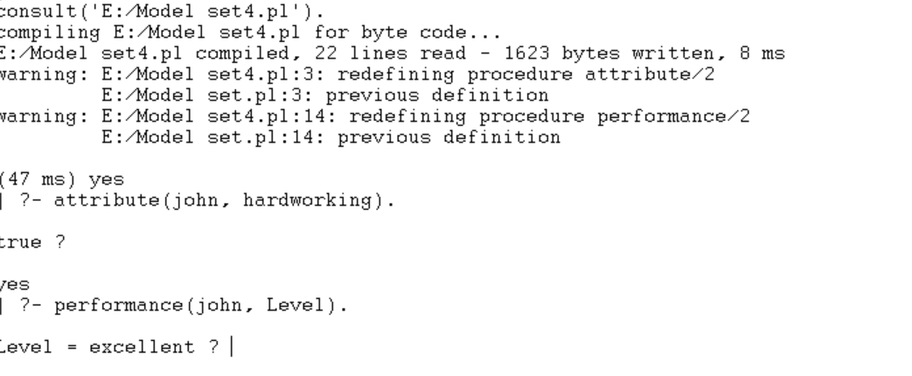

Result
Thus, the Prolog program successfully predicts the academic performance level of students based on their stored attributes and logical rules.

SET:11

SET:12

SET:13

SET:14

SET:15

